Date:30.5.2020

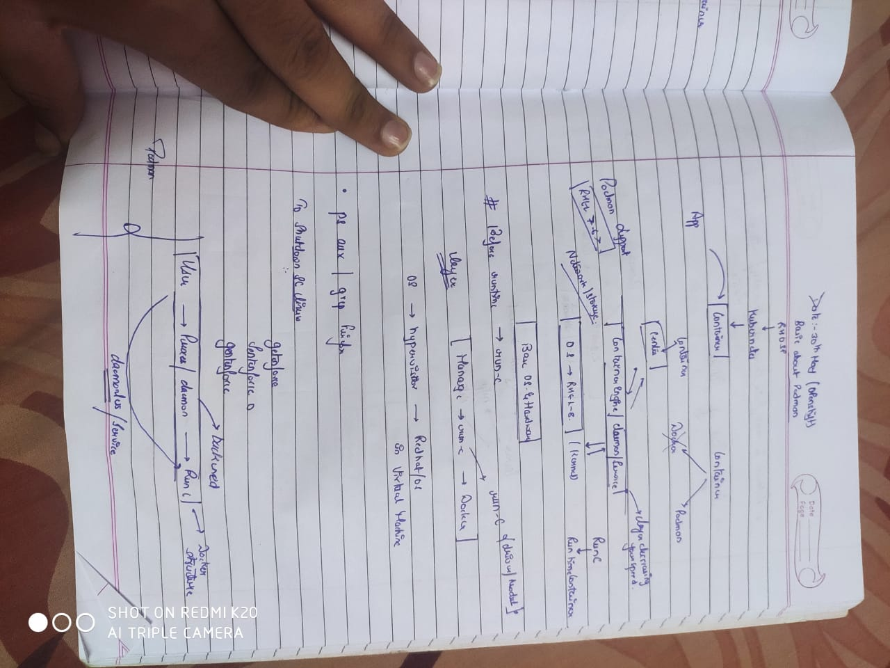

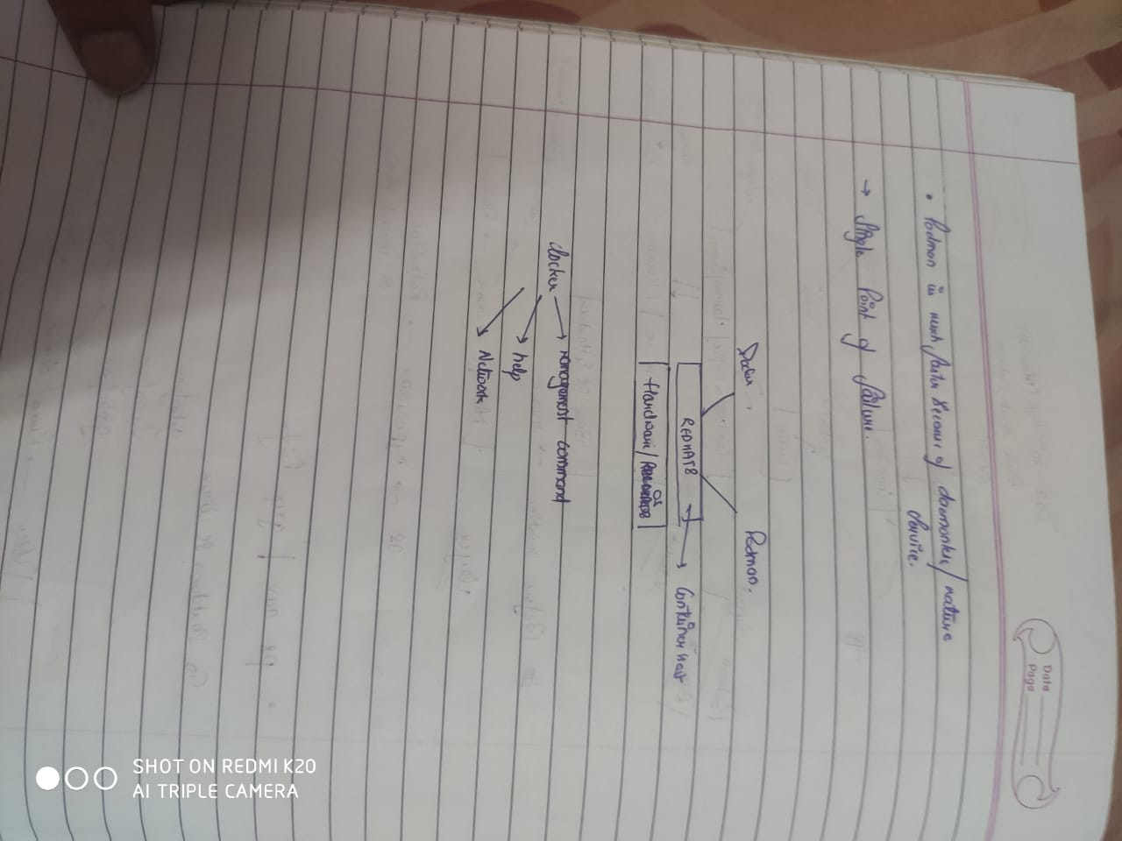

>Docker doesn’t monitor metrics

Metrics:-ram,cpu,bandwidth

Private cloud=on premises (openshift)

[root@localhost ~]# docker info

Client:

Debug Mode: false

Server:

Containers: 0

Running: 0

Paused: 0

Stopped: 0

Images: 45

Server Version: 18.09.0

Storage Driver: overlay2

Backing Filesystem: xfs

Supports d_type: true

Native Overlay Diff: true

Logging Driver: json-file

Cgroup Driver: cgroupfs

Plugins:

Volume: local

Network: bridge host ipvlan macvlan null overlay

Log: awslogs fluentd gcplogs gelf journald json-file local logentries splunk syslog

Swarm: inactive

Runtimes: runc

Default Runtime: runc

Init Binary: docker-init

containerd version: c4446665cb9c30056f4998ed953e6d4ff22c7c39

runc version: 4fc53a81fb7c994640722ac585fa9ca548971871

init version: fec3683

Security Options:

seccomp

Profile: default

Kernel Version: 4.18.0-80.el8.x86_64

Operating System: Red Hat Enterprise Linux 8.0 (Ootpa)

OSType: linux

Architecture: x86_64

CPUs: 1

Total Memory: 1.787GiB

Name: localhost.localdomain

ID: KO2G:M46Q:CKEH:JO2C:6SVT:MHRZ:ZSQI:T6MH:BK5S:ASQK:JMUK:N7EJ

Docker Root Dir: /var/lib/docker

Debug Mode: false

Registry: https://index.docker.io/v1/

Labels:

Experimental: true

Insecure Registries:

127.0.0.0/8

Live Restore Enabled: false

Product License: Community Engine

[root@localhost ~]# ps aux | firefox

Error: no DISPLAY environment variable specified

[root@localhost ~]# ps aux | grep firefox

root 4623 0.0 0.0 221864 992 pts/0 S+ 11:24 0:00 grep --color=auto firefox

[root@localhost ~]# ps aux | grep firefox

root 4625 0.0 0.0 221864 1060 pts/0 S+ 11:24 0:00 grep --color=auto firefox

[root@localhost ~]# echo kill -9 4623

kill -9 4623

[root@localhost ~]# echo kill -9 4625

kill -9 4625

[root@localhost ~]# podman

bash: podman: command not found...

Failed to search for file: Cannot update read-only repo

[root@localhost ~]# systemctl stop docker

[root@localhost ~]# yum install podman

Updating Subscription Management repositories.

Unable to read consumer identity

This system is not registered to Red Hat Subscription Management. You can use subscription-manager to register.

Repository 'docker' is missing name in configuration, using id.

Repository 'dvd' is missing name in configuration, using id.

Repository 'dvd2' is missing name in configuration, using id.

docker 2.5 kB/s | 3.5 kB 00:01

docker 31 kB/s | 24 kB 00:00

dvd 128 kB/s | 3.2 kB 00:00

dvd2 215 kB/s | 2.7 kB 00:00

Extra Packages for Enterprise Linux Modular 8 - x86_64 3.9 kB/s | 8.1 kB 00:02

Extra Packages for Enterprise Linux Modular 8 - x86_64 22 kB/s | 118 kB 00:05

Extra Packages for Enterprise Linux 8 - x86_64 2.9 kB/s | 6.1 kB 00:02

Extra Packages for Enterprise Linux 8 - x86_64 840 kB/s | 6.8 MB 00:08

Jenkins-stable 1.7 kB/s | 2.9 kB 00:01

RPM Fusion for EL 8 - Free - Updates 1.4 kB/s | 3.7 kB 00:02

RPM Fusion for EL 8 - Free - Updates 60 kB/s | 250 kB 00:04

Dependencies resolved.

================================================================================================================================================================================================

Package Arch Version Repository Size

================================================================================================================================================================================================

Installing:

podman x86_64 1.0.0-2.git921f98f.module+el8+2785+ff8a053f dvd 9.0 M

Installing dependencies:

containernetworking-plugins x86_64 0.7.4-3.git9ebe139.module+el8+2769+577ad176 dvd 14 M

containers-common x86_64 1:0.1.32-3.git1715c90.module+el8+2769+577ad176 dvd 31 k

criu x86_64 3.10-7.el8 dvd 482 k

libnet x86_64 1.1.6-15.el8 dvd 67 k

oci-systemd-hook x86_64 1:0.1.15-2.git2d0b8a3.module+el8+2769+577ad176 dvd 39 k

protobuf-c x86_64 1.3.0-4.el8 dvd 37 k

runc x86_64 1.0.0-54.rc5.dev.git2abd837.module+el8+2769+577ad176 dvd 2.3 M

fuse3-libs x86_64 3.2.1-12.el8 dvd2 94 k

Installing weak dependencies:

fuse-overlayfs x86_64 0.3-2.module+el8+2769+577ad176 dvd 48 k

slirp4netns x86_64 0.1-2.dev.gitc4e1bc5.module+el8+2769+577ad176 dvd 55 k

Transaction Summary

================================================================================================================================================================================================

Install 11 Packages

Total size: 26 M

Installed size: 97 M

Is this ok [y/N]: y

Downloading Packages:

Running transaction check

Transaction check succeeded.

Running transaction test

Transaction test succeeded.

Running transaction

Preparing : 1/1

Installing : slirp4netns-0.1-2.dev.gitc4e1bc5.module+el8+2769+577ad176.x86_64 1/11

Installing : fuse3-libs-3.2.1-12.el8.x86_64 2/11

Running scriptlet: fuse3-libs-3.2.1-12.el8.x86_64 2/11

Installing : fuse-overlayfs-0.3-2.module+el8+2769+577ad176.x86_64 3/11

Installing : containers-common-1:0.1.32-3.git1715c90.module+el8+2769+577ad176.x86_64 4/11

Installing : protobuf-c-1.3.0-4.el8.x86_64 5/11

Installing : oci-systemd-hook-1:0.1.15-2.git2d0b8a3.module+el8+2769+577ad176.x86_64 6/11

Installing : libnet-1.1.6-15.el8.x86_64 7/11

Running scriptlet: libnet-1.1.6-15.el8.x86_64 7/11

Installing : criu-3.10-7.el8.x86_64 8/11

Installing : runc-1.0.0-54.rc5.dev.git2abd837.module+el8+2769+577ad176.x86_64 9/11

Installing : containernetworking-plugins-0.7.4-3.git9ebe139.module+el8+2769+577ad176.x86_64 10/11

Installing : podman-1.0.0-2.git921f98f.module+el8+2785+ff8a053f.x86_64 11/11

Running scriptlet: podman-1.0.0-2.git921f98f.module+el8+2785+ff8a053f.x86_64 11/11

Verifying : containernetworking-plugins-0.7.4-3.git9ebe139.module+el8+2769+577ad176.x86_64 1/11

Verifying : containers-common-1:0.1.32-3.git1715c90.module+el8+2769+577ad176.x86_64 2/11

Verifying : criu-3.10-7.el8.x86_64 3/11

Verifying : fuse-overlayfs-0.3-2.module+el8+2769+577ad176.x86_64 4/11

Verifying : libnet-1.1.6-15.el8.x86_64 5/11

Verifying : oci-systemd-hook-1:0.1.15-2.git2d0b8a3.module+el8+2769+577ad176.x86_64 6/11

Verifying : podman-1.0.0-2.git921f98f.module+el8+2785+ff8a053f.x86_64 7/11

Verifying : protobuf-c-1.3.0-4.el8.x86_64 8/11

Verifying : runc-1.0.0-54.rc5.dev.git2abd837.module+el8+2769+577ad176.x86_64 9/11

Verifying : slirp4netns-0.1-2.dev.gitc4e1bc5.module+el8+2769+577ad176.x86_64 10/11

Verifying : fuse3-libs-3.2.1-12.el8.x86_64 11/11

Installed products updated.

Installed:

podman-1.0.0-2.git921f98f.module+el8+2785+ff8a053f.x86_64 fuse-overlayfs-0.3-2.module+el8+2769+577ad176.x86_64

slirp4netns-0.1-2.dev.gitc4e1bc5.module+el8+2769+577ad176.x86_64 containernetworking-plugins-0.7.4-3.git9ebe139.module+el8+2769+577ad176.x86_64

containers-common-1:0.1.32-3.git1715c90.module+el8+2769+577ad176.x86_64 criu-3.10-7.el8.x86_64

libnet-1.1.6-15.el8.x86_64 oci-systemd-hook-1:0.1.15-2.git2d0b8a3.module+el8+2769+577ad176.x86_64

protobuf-c-1.3.0-4.el8.x86_64 runc-1.0.0-54.rc5.dev.git2abd837.module+el8+2769+577ad176.x86_64

fuse3-libs-3.2.1-12.el8.x86_64

Complete!

[root@localhost ~]# yum module list

Updating Subscription Management repositories.

Unable to read consumer identity

This system is not registered to Red Hat Subscription Management. You can use subscription-manager to register.

Repository 'docker' is missing name in configuration, using id.

Repository 'dvd' is missing name in configuration, using id.

Repository 'dvd2' is missing name in configuration, using id.

Last metadata expiration check: 0:05:15 ago on Sun 31 May 2020 11:44:01 AM IST.

Name Stream Profiles Summary

389-ds 1.4 389 Directory Server (base)

ant 1.10 [d] common [d] Java build tool

container-tools 1.0 common [d] Common tools and dependencies for container runtimes

container-tools rhel8 [d][e] common [d] Common tools and dependencies for container runtimes

freeradius 3.0 [d] server [d] High-performance and highly configurable free RADIUS server

gimp 2.8 [d] common [d], devel gimp module

go-toolset rhel8 [d] common [d] Go

httpd 2.4 [d][e] common [d], devel, minimal Apache HTTP Server

idm DL1 common [d], adtrust, client, dns, server The Red Hat Enterprise Linux Identity Management system module

idm client [d] common [d] RHEL IdM long term support client module

inkscape 0.92.3 [d] common [d] Vector-based drawing program using SVG

javapackages-runtime 201801 [d][e] common [d] Basic runtime utilities to support Java applications

libselinux-python 2.8 common Python 2 bindings for libselinux

llvm-toolset rhel8 [d][e] common [d] LLVM

mailman 2.1 [d] common [d] Electronic mail discussion and e-newsletter lists managing software

mariadb 10.3 [d] client, server [d], galera MariaDB Module

maven 3.5 [d] common [d] Java project management and project comprehension tool

mercurial 4.8 [d] common [d] Mercurial -- a distributed SCM

mod_auth_openidc 2.3 Apache module suporting OpenID Connect authentication

mysql 8.0 [d] client, server [d] MySQL Module

nginx 1.14 [d] common [d] nginx webserver

nodejs 10 [d] common [d], development, minimal, s2i Javascript runtime

parfait 0.5 common Parfait Module

perl 5.24 common [d], minimal Practical Extraction and Report Language

perl 5.26 [d] common [d], minimal Practical Extraction and Report Language

perl-App-cpanminus 1.7044 [d] common [d] Get, unpack, build and install CPAN modules

perl-DBD-MySQL 4.046 [d] common [d] A MySQL interface for Perl

perl-DBD-Pg 3.7 [d] common [d] A PostgreSQL interface for Perl

perl-DBD-SQLite 1.58 [d] common [d] SQLite DBI driver

perl-DBI 1.641 [d] common [d] A database access API for Perl

perl-FCGI 0.78 [d] common [d] FastCGI Perl bindings

perl-YAML 1.24 [d] common [d] Perl parser for YAML

php 7.2 [d] common [d], devel, minimal PHP scripting language

pki-core 10.6 PKI Core

pki-deps 10.6 PKI Dependencies

postgresql 10 [d] client, server [d] PostgreSQL server and client module

postgresql 9.6 client, server [d] PostgreSQL server and client module

python27 2.7 [d] common [d] Python programming language, version 2.7

python36 3.6 [d][e] common [d], build Python programming language, version 3.6

redis 5 [d] common [d] Redis persistent key-value database

rhn-tools 1.0 [d] common [d] Red Hat Satellite 5 tools for RHEL

ruby 2.5 [d] common [d] An interpreter of object-oriented scripting language

rust-toolset rhel8 [d] common [d] Rust

satellite-5-client 1.0 [d][e] common [d], gui Red Hat Satellite 5 client packages

scala 2.10 [d] common [d] A hybrid functional/object-oriented language for the JVM

squid 4 [d] common [d] Squid - Optimising Web Delivery

subversion 1.10 [d] common [d], server Apache Subversion

swig 3.0 [d] common [d], complete Connects C/C++/Objective C to some high-level programming languages

varnish 6 [d] common [d] Varnish HTTP cache

virt rhel [d][e] common [d] Virtualization module

Extra Packages for Enterprise Linux Modular 8 - x86_64

Name Stream Profiles Summary

389-directory-server stable minimal, legacy, default [d] 389 Directory Server

389-directory-server testing minimal, legacy, default [d] 389 Directory Server

avocado latest minimal, default Framework with tools and libraries for Automated Testing

cobbler 3 default [d] Versatile Linux deployment server

libuv epel8-buildroot devel [d] libuv-devel for EPEL 8

nginx 1.18 common nginx webserver

nginx mainline common nginx webserver

nodejs 12 development, minimal, default Javascript runtime

nodejs 13 development, minimal, default Javascript runtime

Hint: [d]efault, [e]nabled, [x]disabled, [i]nstalled

[root@localhost ~]# yum module install container-tools

Updating Subscription Management repositories.

Unable to read consumer identity

This system is not registered to Red Hat Subscription Management. You can use subscription-manager to register.

Repository 'docker' is missing name in configuration, using id.

Repository 'dvd' is missing name in configuration, using id.

Repository 'dvd2' is missing name in configuration, using id.

Last metadata expiration check: 0:06:33 ago on Sun 31 May 2020 11:44:01 AM IST.

Dependencies resolved.

================================================================================================================================================================================================

Package Arch Version Repository Size

================================================================================================================================================================================================

Installing group/module packages:

buildah x86_64 1.5-3.gite94b4f9.module+el8+2769+577ad176 dvd 5.3 M

oci-umount x86_64 2:2.3.4-2.git87f9237.module+el8+2769+577ad176 dvd 38 k

skopeo x86_64 1:0.1.32-3.git1715c90.module+el8+2769+577ad176 dvd 4.8 M

Installing module profiles:

container-tools/common

Transaction Summary

================================================================================================================================================================================================

Install 3 Packages

Total size: 10 M

Installed size: 39 M

Is this ok [y/N]: y

Downloading Packages:

Running transaction check

Transaction check succeeded.

Running transaction test

Transaction test succeeded.

Running transaction

Preparing : 1/1

Installing : skopeo-1:0.1.32-3.git1715c90.module+el8+2769+577ad176.x86_64 1/3

Installing : oci-umount-2:2.3.4-2.git87f9237.module+el8+2769+577ad176.x86_64 2/3

Installing : buildah-1.5-3.gite94b4f9.module+el8+2769+577ad176.x86_64 3/3

Running scriptlet: buildah-1.5-3.gite94b4f9.module+el8+2769+577ad176.x86_64 3/3

Verifying : buildah-1.5-3.gite94b4f9.module+el8+2769+577ad176.x86_64 1/3

Verifying : oci-umount-2:2.3.4-2.git87f9237.module+el8+2769+577ad176.x86_64 2/3

Verifying : skopeo-1:0.1.32-3.git1715c90.module+el8+2769+577ad176.x86_64 3/3

Installed products updated.

Installed:

buildah-1.5-3.gite94b4f9.module+el8+2769+577ad176.x86_64 oci-umount-2:2.3.4-2.git87f9237.module+el8+2769+577ad176.x86_64 skopeo-1:0.1.32-3.git1715c90.module+el8+2769+577ad176.x86_64

Complete!

[root@localhost ~]# systemctl start podman

Failed to start podman.service: Unit podman.service not found.

[root@localhost ~]# podman ps

CONTAINER ID IMAGE COMMAND CREATED STATUS PORTS NAMES

[root@localhost ~]# podman images

[root@localhost ~]# podman centos:7

Command "centos:7" not found.

See `podman --help`.

[root@localhost ~]# podman pull centos:7

Trying to pull registry.redhat.io/centos:7...Failed

Trying to pull quay.io/centos:7...Failed

Trying to pull docker.io/centos:7...Getting image source signatures

Copying blob 524b0c1e57f8: 72.36 MiB / 72.36 MiB [=========================] 25s

Copying config b5b4d78bc90c: 2.73 KiB / 2.73 KiB [==========================] 0s

Writing manifest to image destination

Storing signatures

b5b4d78bc90ccd15806443fb881e35b5ddba924e2f475c1071a38a3094c3081d

[root@localhost ~]# ps aux | grep podman

root 8509 0.0 0.0 221864 1096 pts/0 S+ 11:54 0:00 grep --color=auto podman

[root@localhost ~]# podman run -dit --name c1 centos:7

25ca19fcf3da7149434fe2c07d26d46ae2edf85d441f6c262c591bb8b40b1487

[root@localhost ~]# podman ps

CONTAINER ID IMAGE COMMAND CREATED STATUS PORTS NAMES

25ca19fcf3da docker.io/library/centos:7 /bin/bash 12 seconds ago Up 9 seconds ago c1

[root@localhost ~]# ps aux | grep podman

root 8607 0.0 0.1 85976 1932 ? Ssl 11:55 0:00 /usr/libexec/podman/conmon -s -c 25ca19fcf3da7149434fe2c07d26d46ae2edf85d441f6c262c591bb8b40b1487 -u 25ca19fcf3da7149434fe2c07d26d46ae2edf85d441f6c262c591bb8b40b1487 -r /usr/bin/runc -b /var/lib/containers/storage/overlay-containers/25ca19fcf3da7149434fe2c07d26d46ae2edf85d441f6c262c591bb8b40b1487/userdata -p /var/run/containers/storage/overlay-containers/25ca19fcf3da7149434fe2c07d26d46ae2edf85d441f6c262c591bb8b40b1487/userdata/pidfile -l /var/lib/containers/storage/overlay-containers/25ca19fcf3da7149434fe2c07d26d46ae2edf85d441f6c262c591bb8b40b1487/userdata/ctr.log --exit-dir /var/run/libpod/exits --exit-command /usr/bin/podman --exit-command-arg --root --exit-command-arg /var/lib/containers/storage --exit-command-arg --runroot --exit-command-arg /var/run/containers/storage --exit-command-arg --log-level --exit-command-arg error --exit-command-arg --cgroup-manager --exit-command-arg systemd --exit-command-arg --tmpdir --exit-command-arg /var/run/libpod --exit-command-arg --storage-driver --exit-command-arg overlay --exit-command-arg container --exit-command-arg cleanup --exit-command-arg 25ca19fcf3da7149434fe2c07d26d46ae2edf85d441f6c262c591bb8b40b1487 --socket-dir-path /var/run/libpod/socket -t --log-level error

root 8674 0.0 0.0 221864 976 pts/0 S+ 11:55 0:00 grep --color=auto podman

[root@localhost ~]# podman run -dit --name c2 centos:7

82530be91f009f4c7155d2df382110ff1aeab4ebf6064b4731b4ca977498a501

[root@localhost ~]# ps aux | grep podman

root 8607 0.0 0.1 85976 1932 ? Ssl 11:55 0:00 /usr/libexec/podman/conmon -s -c 25ca19fcf3da7149434fe2c07d26d46ae2edf85d441f6c262c591bb8b40b1487 -u 25ca19fcf3da7149434fe2c07d26d46ae2edf85d441f6c262c591bb8b40b1487 -r /usr/bin/runc -b /var/lib/containers/storage/overlay-containers/25ca19fcf3da7149434fe2c07d26d46ae2edf85d441f6c262c591bb8b40b1487/userdata -p /var/run/containers/storage/overlay-containers/25ca19fcf3da7149434fe2c07d26d46ae2edf85d441f6c262c591bb8b40b1487/userdata/pidfile -l /var/lib/containers/storage/overlay-containers/25ca19fcf3da7149434fe2c07d26d46ae2edf85d441f6c262c591bb8b40b1487/userdata/ctr.log --exit-dir /var/run/libpod/exits --exit-command /usr/bin/podman --exit-command-arg --root --exit-command-arg /var/lib/containers/storage --exit-command-arg --runroot --exit-command-arg /var/run/containers/storage --exit-command-arg --log-level --exit-command-arg error --exit-command-arg --cgroup-manager --exit-command-arg systemd --exit-command-arg --tmpdir --exit-command-arg /var/run/libpod --exit-command-arg --storage-driver --exit-command-arg overlay --exit-command-arg container --exit-command-arg cleanup --exit-command-arg 25ca19fcf3da7149434fe2c07d26d46ae2edf85d441f6c262c591bb8b40b1487 --socket-dir-path /var/run/libpod/socket -t --log-level error

root 8752 0.0 0.1 85976 1924 ? Ssl 11:56 0:00 /usr/libexec/podman/conmon -s -c 82530be91f009f4c7155d2df382110ff1aeab4ebf6064b4731b4ca977498a501 -u 82530be91f009f4c7155d2df382110ff1aeab4ebf6064b4731b4ca977498a501 -r /usr/bin/runc -b /var/lib/containers/storage/overlay-containers/82530be91f009f4c7155d2df382110ff1aeab4ebf6064b4731b4ca977498a501/userdata -p /var/run/containers/storage/overlay-containers/82530be91f009f4c7155d2df382110ff1aeab4ebf6064b4731b4ca977498a501/userdata/pidfile -l /var/lib/containers/storage/overlay-containers/82530be91f009f4c7155d2df382110ff1aeab4ebf6064b4731b4ca977498a501/userdata/ctr.log --exit-dir /var/run/libpod/exits --exit-command /usr/bin/podman --exit-command-arg --root --exit-command-arg /var/lib/containers/storage --exit-command-arg --runroot --exit-command-arg /var/run/containers/storage --exit-command-arg --log-level --exit-command-arg error --exit-command-arg --cgroup-manager --exit-command-arg systemd --exit-command-arg --tmpdir --exit-command-arg /var/run/libpod --exit-command-arg --storage-driver --exit-command-arg overlay --exit-command-arg container --exit-command-arg cleanup --exit-command-arg 82530be91f009f4c7155d2df382110ff1aeab4ebf6064b4731b4ca977498a501 --socket-dir-path /var/run/libpod/socket -t --log-level error

root 8783 0.0 0.0 221864 1064 pts/0 R+ 11:56 0:00 grep --color=auto podman

[root@localhost ~]# podman rm -f c1

25ca19fcf3da7149434fe2c07d26d46ae2edf85d441f6c262c591bb8b40b1487

[root@localhost ~]# ps aux | grep podman

root 8752 0.0 0.1 85976 1924 ? Ssl 11:56 0:00 /usr/libexec/podman/conmon -s -c 82530be91f009f4c7155d2df382110ff1aeab4ebf6064b4731b4ca977498a501 -u 82530be91f009f4c7155d2df382110ff1aeab4ebf6064b4731b4ca977498a501 -r /usr/bin/runc -b /var/lib/containers/storage/overlay-containers/82530be91f009f4c7155d2df382110ff1aeab4ebf6064b4731b4ca977498a501/userdata -p /var/run/containers/storage/overlay-containers/82530be91f009f4c7155d2df382110ff1aeab4ebf6064b4731b4ca977498a501/userdata/pidfile -l /var/lib/containers/storage/overlay-containers/82530be91f009f4c7155d2df382110ff1aeab4ebf6064b4731b4ca977498a501/userdata/ctr.log --exit-dir /var/run/libpod/exits --exit-command /usr/bin/podman --exit-command-arg --root --exit-command-arg /var/lib/containers/storage --exit-command-arg --runroot --exit-command-arg /var/run/containers/storage --exit-command-arg --log-level --exit-command-arg error --exit-command-arg --cgroup-manager --exit-command-arg systemd --exit-command-arg --tmpdir --exit-command-arg /var/run/libpod --exit-command-arg --storage-driver --exit-command-arg overlay --exit-command-arg container --exit-command-arg cleanup --exit-command-arg 82530be91f009f4c7155d2df382110ff1aeab4ebf6064b4731b4ca977498a501 --socket-dir-path /var/run/libpod/socket -t --log-level error

root 8894 0.0 0.0 221864 956 pts/0 S+ 11:56 0:00 grep --color=auto podman

[root@localhost ~]# podman info

host:

BuildahVersion: 1.6-dev

Conmon:

package: podman-1.0.0-2.git921f98f.module+el8+2785+ff8a053f.x86_64

path: /usr/libexec/podman/conmon

version: 'conmon version 1.14.0-dev, commit: be8255a19cda8a598d76dfa49e16e337769d4528-dirty'

Distribution:

distribution: '"rhel"'

version: "8.0"

MemFree: 111046656

MemTotal: 1918275584

OCIRuntime:

package: runc-1.0.0-54.rc5.dev.git2abd837.module+el8+2769+577ad176.x86_64

path: /usr/bin/runc

version: 'runc version spec: 1.0.0'

SwapFree: 2037903360

SwapTotal: 2222977024

arch: amd64

cpus: 1

hostname: localhost.localdomain

kernel: 4.18.0-80.el8.x86_64

os: linux

rootless: false

uptime: 1h 25m 3.99s (Approximately 0.04 days)

insecure registries:

registries: []

registries:

registries:

- registry.redhat.io

- quay.io

- docker.io

store:

ConfigFile: /etc/containers/storage.conf

ContainerStore:

number: 1

GraphDriverName: overlay

GraphOptions: null

GraphRoot: /var/lib/containers/storage

GraphStatus:

Backing Filesystem: xfs

Native Overlay Diff: "true"

Supports d_type: "true"

ImageStore:

number: 1

RunRoot: /var/run/containers/storage

[root@localhost ~]#

[root@localhost ~]# systemctl start docker

[root@localhost ~]# docker ps

CONTAINER ID IMAGE COMMAND CREATED STATUS PORTS NAMES

[root@localhost ~]# podman ps

CONTAINER ID IMAGE COMMAND CREATED STATUS PORTS NAMES

82530be91f00 docker.io/library/centos:7 /bin/bash 13 minutes ago Up 13 minutes ago c2

**OPENSHIFT-part2:**

